**Lab 8**

**Create a new workspace and use the dwsalesfact script provided in eLearning. For each problem, enter your query and attach a screen shot of the result set. Each problem is worth 2 points.**

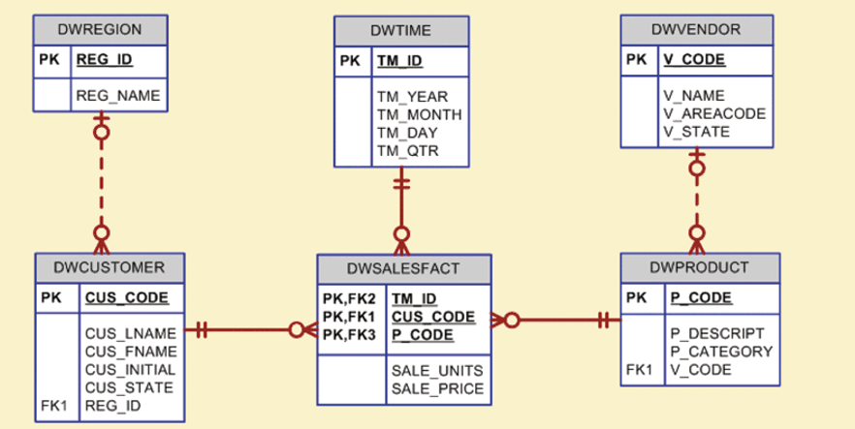

**1a. Write the SQL command to list the total sales by region and customer.**

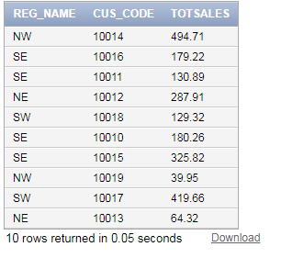

**select dr.reg_name, dc.cus_code, sum(ddsf.sale_units * ddsf.sale_price) as "TOTSALES"**

**from dwregion dr, dwcustomer dc, dwdaysalesfact ddsf**

**where dr.reg_id = dc.reg_id**

**and dc.cus_code = ddsf.cus_code**

**group by dr.reg_name, dc.cus_code**

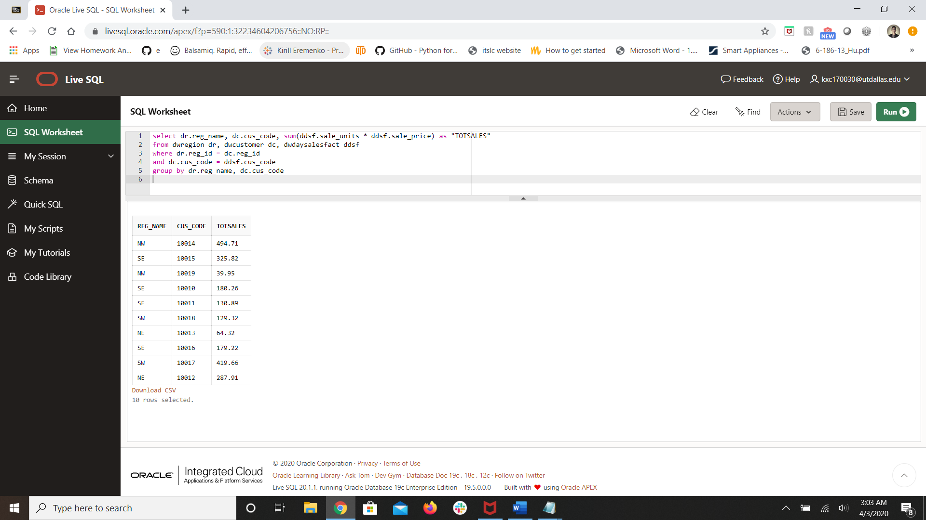

**1b. Modify the SQL command to include subtotals by region and a grand total for all sales.**

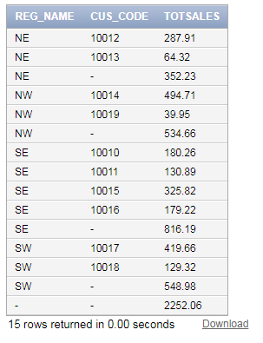

**select dr.reg_name, dc.cus_code, sum(ddsf.sale_units * ddsf.sale_price) as "TOTSALES"**

**from dwregion dr, dwcustomer dc, dwdaysalesfact ddsf**

**where dr.reg_id = dc.reg_id**

**and dc.cus_code = ddsf.cus_code**

**group by rollup(dr.reg_name, dc.cus_code)**

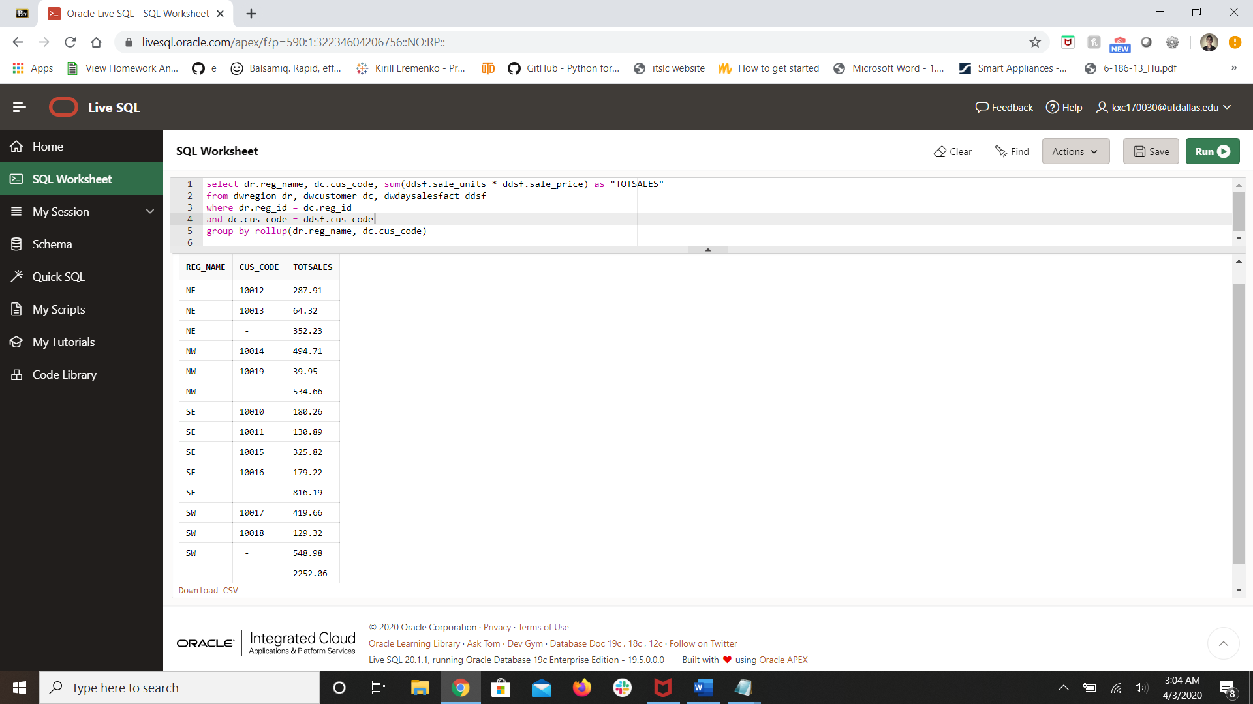

**2a. Write the SQL command to list the total sales by month and product category.**

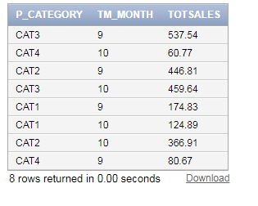

**select dp.p_category, dt.tm_month, sum(ddsf.sale_units * ddsf.sale_price) as "TOTSALES"**

**from dwtime dt, dwdaysalesfact ddsf, dwproduct dp**

**where dt.tm_id = ddsf.tm_id**

**and ddsf.p_code = dp.p_code**

**group by dp.p_category, dt.tm_month**

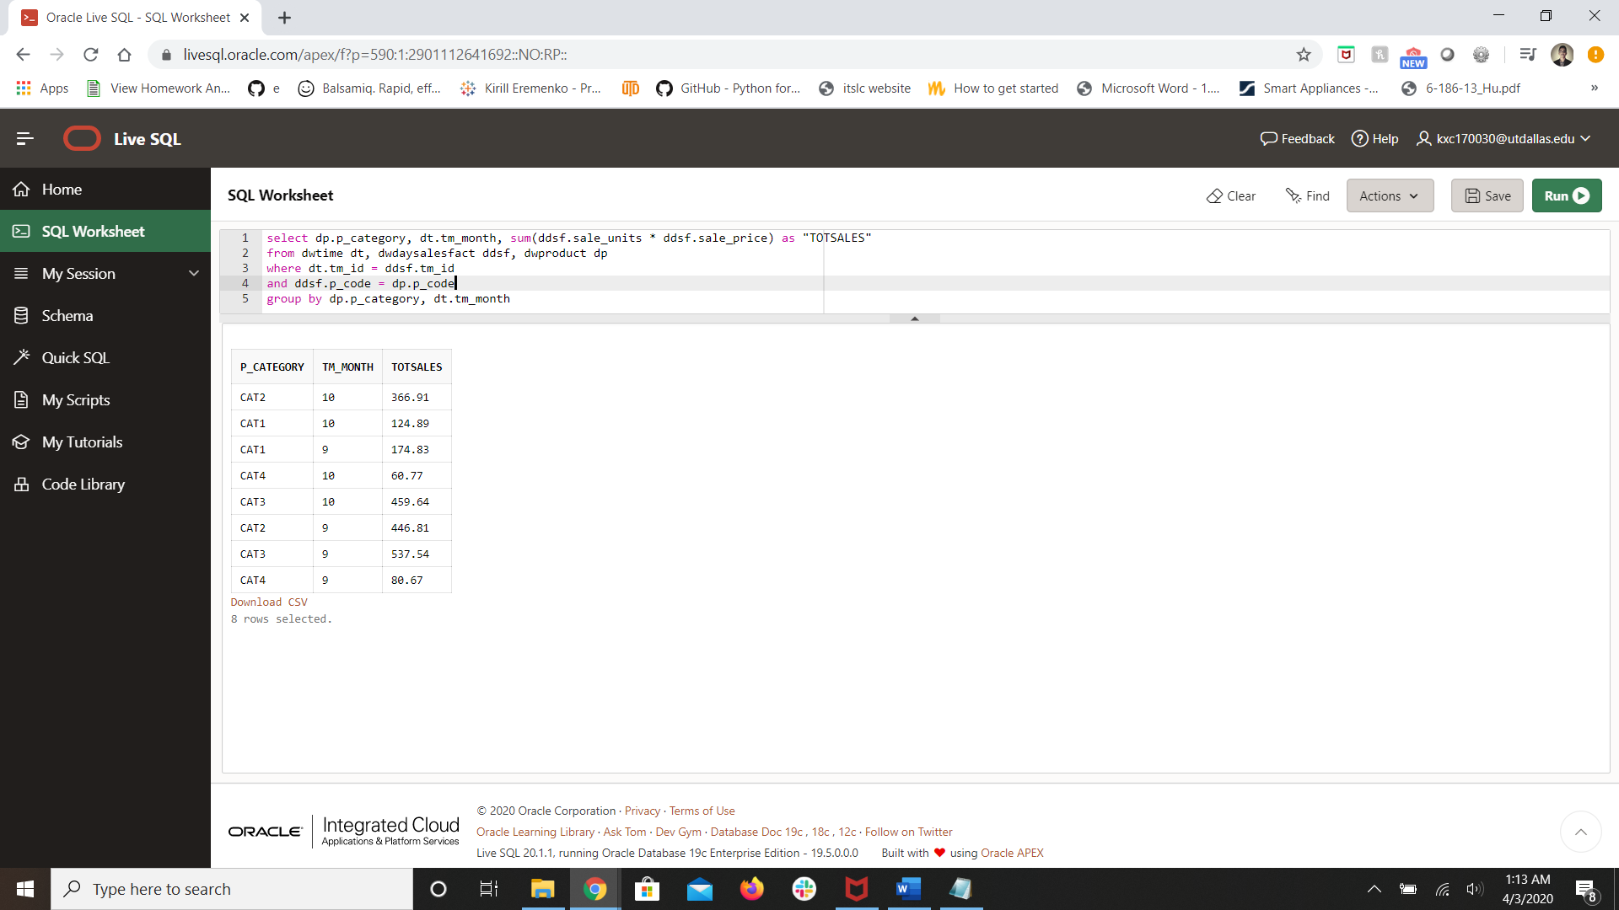

**2b. Modify the SQL command to include subtotals by month and a grand total for all sales.**

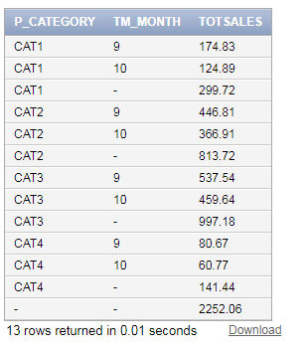

**select dp.p_category, dt.tm_month, sum(ddsf.sale_units * ddsf.sale_price) as "TOTSALES"**

**from dwtime dt, dwdaysalesfact ddsf, dwproduct dp**

**where dt.tm_id = ddsf.tm_id**

**and ddsf.p_code = dp.p_code**

**group by rollup(dp.p_category, dt.tm_month)**

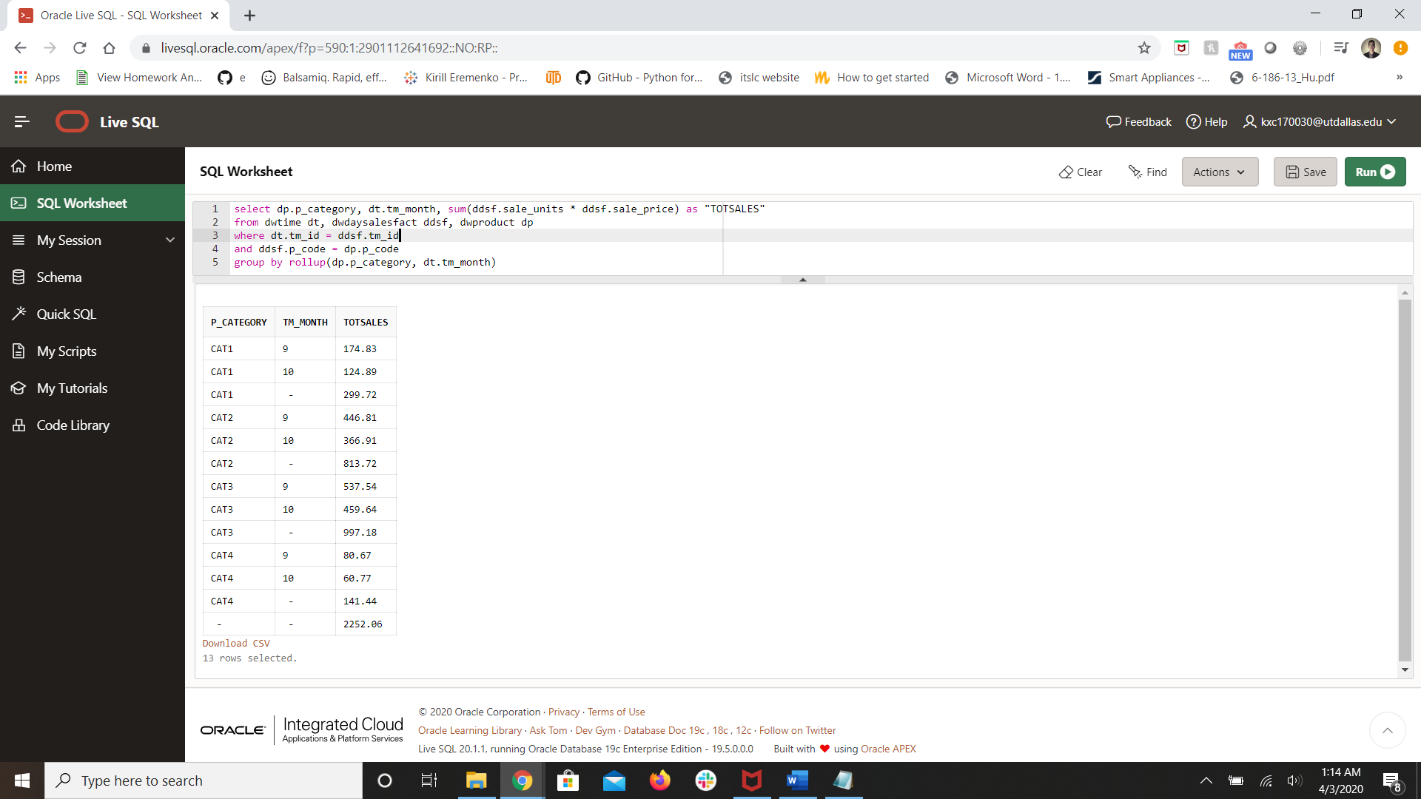

1. **Show the ranking of products by total sales. Hint: you will need to use a subquery to rollup the total sales. I have provided a query. Modify it to get the results.**

WITH top_product AS

(SELECT p_code, sum(sale_units * sale_price) as totsales

FROM dwdaysalesfact

group by p_code)

SELECT p_code, totsales, ???

FROM top_product

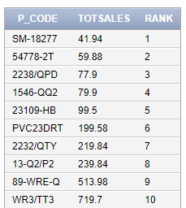

**WITH top_product AS**

**(SELECT p_code, sum(sale_units * sale_price) as totsales**

**FROM dwdaysalesfact**

**group by p_code)**

**SELECT p_code, totsales, rank() over (order by totsales)**

**FROM top_product**

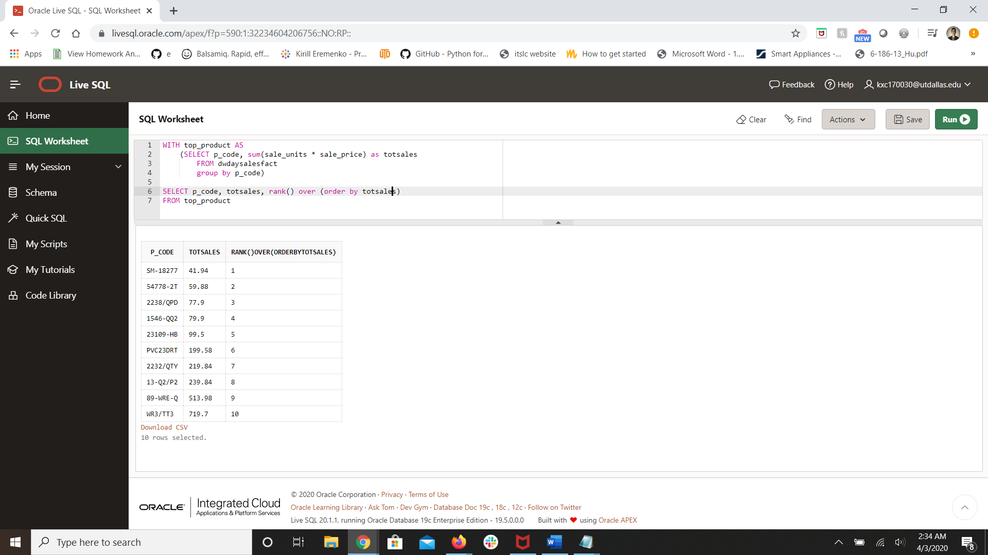

1. **Provide a running summary of sales in order by day for year 2015 and month 9. Display the product code the year, the month, the day, and the running summary.**

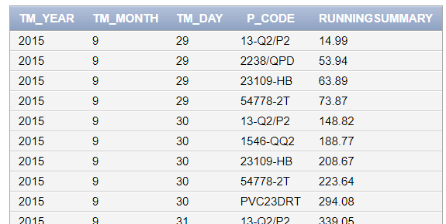

**select dt.tm_year, dt.tm_month, dt.tm_day, ddsf.p_code,**

**sum(ddsf.sale_units * ddsf.sale_price) over (order by dt.tm_day, ddsf.p_code) as "RUNNINGSUMMARY"**

**from dwtime dt, dwdaysalesfact ddsf**

**where dt.tm_id = ddsf.tm_id**

**and dt.tm_year = 2015**

**and dt.tm_month = 9**

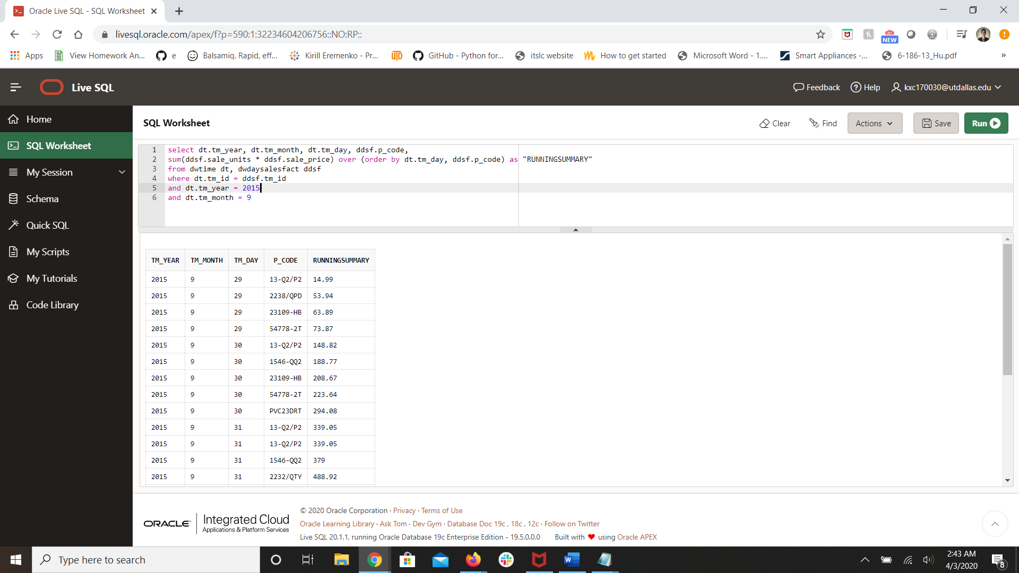

1. **Show the product sales by region in a cross tabular format.**

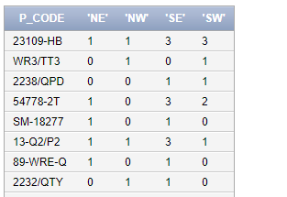

**select * from**

**( select p_code, reg_name**

**from dwregion dr, dwcustomer dc, dwdaysalesfact ddsf**

**where dr.reg_id = dc.reg_id**

**and dc.cus_code = ddsf.cus_code**

**)**

**pivot**

**(**

**count(reg_name)**

**for reg_name in ('NE', 'NW', 'SE', 'SW')**

**)**

